 

Internet Software Architecture

Report on Weather Application

Student Id: 2408414

Student Name: Shashank Pandey

Group: L4CG20

Module Leader: Bishal Khadka

Tutor: Jeshmi Rajak

Submission Date: 2024-02-15

Table of Contents

Prototype 1

Introduction**1**

Strong Point2

Weakness3

Conclusion……………………………………………………………………………………….4

Prototype 2

Introduction………………………………………………………………………………………5

Strong Point……………………………………………………………………………………..6

Weakness……………………………………………………………………………………….7

Conclusion………………………………………………………………………………………8

Prototype 3

Introduction…………………………………………………………………………………..9-10

Strong Point…………………………………………………………………………………….10

Weak Point…………………………………………………………………………………….10

Web Hosting.……………………………………………………………………………….11-12

Local Storage…………………………………………………………………………………..13

UML Diagrams…………………………………………………………………………….14-16

Conclusion……………………………………………………………………………………..17

Prototype 1:

Introduction:

* Weather App the coursework of ISA (Internet Software Architecture) module is one of the important coursework which aims to offer user-friendly interface with advanced features and helps to provide information to the user about various Weather conditions which includes temperature, humidity, pressure, speed of wind etc. HTML, CSS, and JavaScript were used in this prototype 1 for the development of this weather app. Here the weather of all the cities is fetched through API (Application Programming Interface). At first, when we open the weather app, weather of Dibrugarh which is also the default city of my project displays in the screen. Here in this project weather information like humidity, pressure, temperature, and speed of wind of different cities is shown according to the users need. The project also displays the weather of that particular date and time.

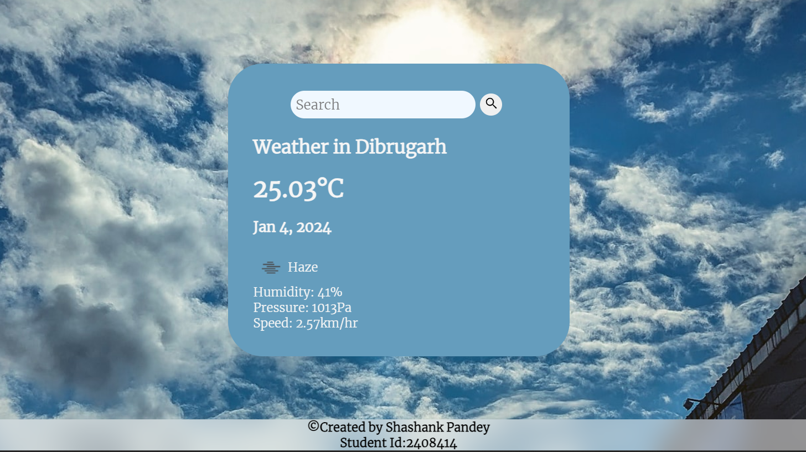

The above picture is a sample of my coursework. Here the structure of this project is made through the use of HTML, the design is made through the use of CSS and finally JavaScript is used to provide the application logic and also make this project work.

Strong Points:

* The data displayed in this Weather Application is in real time and displays the data of Dibrugarh which is also the default city which was provided to me by my tutor.
* Users depend on real time information, so this weather app provides real time information and also uses clear icons and organized information which enhances the overall user experience.
* It not only displays the weather of my default city but also allows users to see and monitor the weather conditions for multiple locations as per the users need.
* Since the development of this weather app is simple, it is easy to understand and provides wonderful user experience.
* Not only it displays the weather of the inputted location but also displays the message, “City Not Found!” if the input location is false or does not exist.

Weakness:

* The weather app won’t run if there is no Internet connection or run slow if the internet connection is poor.
* The weather app only displays real time weather and is not able to display the weather of past days or the upcoming days.
* Since the weather app is made through a simple architecture it won’t be able to handle complex issues.
* Since all the weather information is dependent on open weather API, the data won’t be displayed if the server experiences any sort of updates or downtime.

Conclusion:

* In conclusion, this coursework provides practical knowledge about the development of weather applications and also teaches students how to create, design and provide application logic to the project. This project also teaches students how to fetch the weather data through API and also engages students in a creative and critical thinking activities.

Prototype 2:

Introduction

* This coursework is based on PHP and database. Coursework 1 which was done earlier was based on HTML, CSS, JS while this time we had to use the concept of PHP and Database in order to fetch the weather data of past 7 days. In order to complete this prototype 2 one must be clear about the concept of HTML, CSS, JS, PHP and Database.

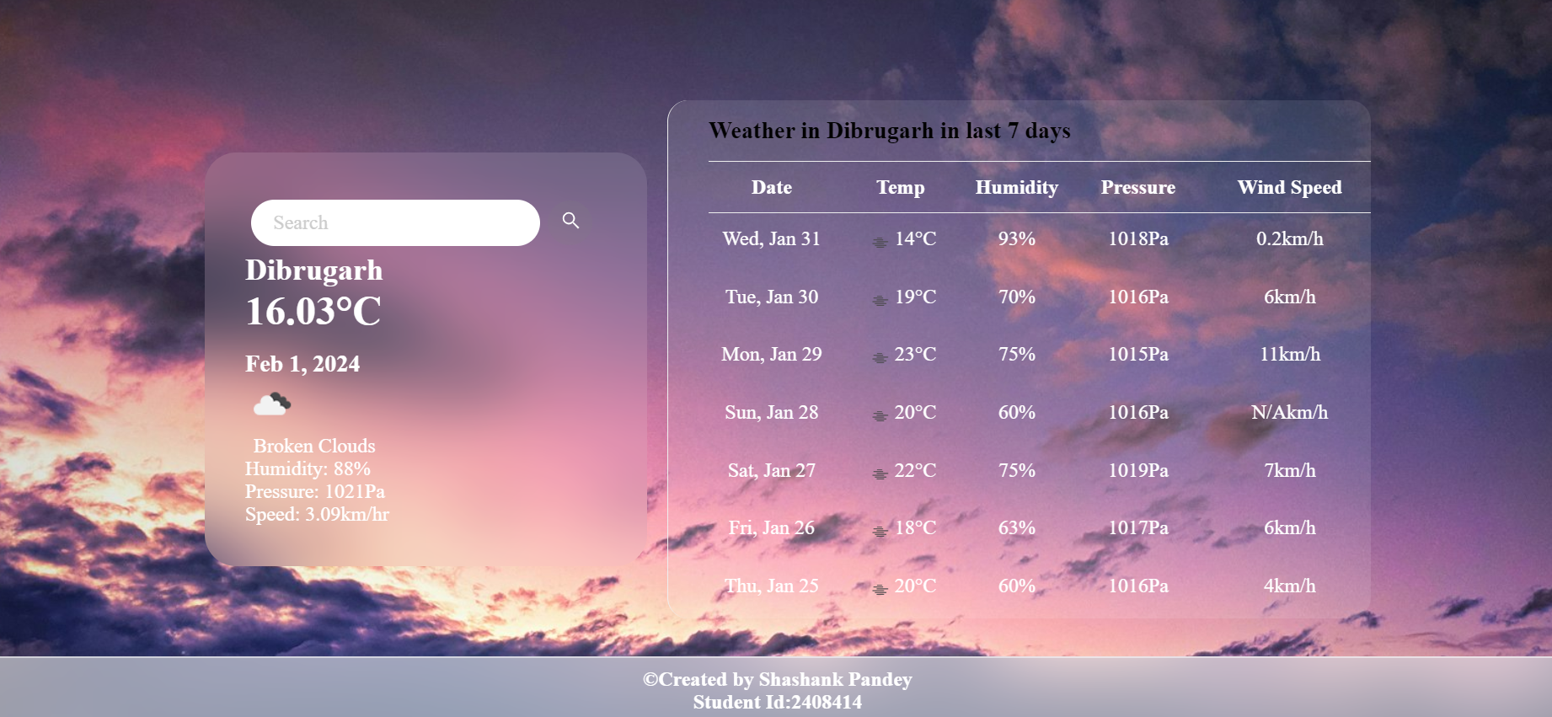

Strong Points:

* Users depend on real time information, so this weather app provides real time information and also uses clear icons and organized information which enhances the overall user experience.
* Since the development of this weather app is simple, it is easy to understand and provides wonderful user experience.
* It not only gives the data of the real time but also gives the weather data of the past seven days of the default city.
* It uses clear images of icons so that the user can easily understand the type of weather occurring in that particular city.
* The weather app provides a high value on user-friendly navigations so that the user can understand easily.
* The data are retrieved using the Open Weather Api, so it provides effective data retrieval.

Weakness:

* The weather app won’t run if there is no Internet connection or run slow if the internet connection is poor.
* Since the weather app is made through a simple architecture it won’t be able to handle complex issues.
* Since all the weather information is dependent on open weather API, the data won’t be displayed if the server experiences any sort of updates or downtime.
* The app cannot show the past data of others except the default city and the app does not show hourly and weekly forecasts.

Conclusion:

* In conclusion, this coursework provides practical knowledge about the development of weather applications and also teaches students how to create, design and provide application logic to the project. This project also teaches students how to fetch the weather data through API and also engages students in creative and critical thinking activities.

Prototype 3:

Introduction:

* The third prototype is about the use of client-side caching and using local storage in order to display the weather of already searched locations and also the weather of default city without the use of Internet i.e. in the absence of the internet connection. Here in this prototype, I have hosted my weather project online in the link (<http://shashank77.kesug.com/weather.html>) or (<https://shashank7.000webhostapp.com/weather.html>) And everyone are able to access my weather app with the help of this given link.
* Showing the result of my default city:

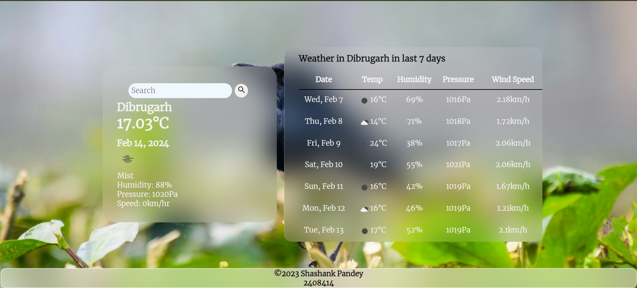

* Showing the result of the searched city:

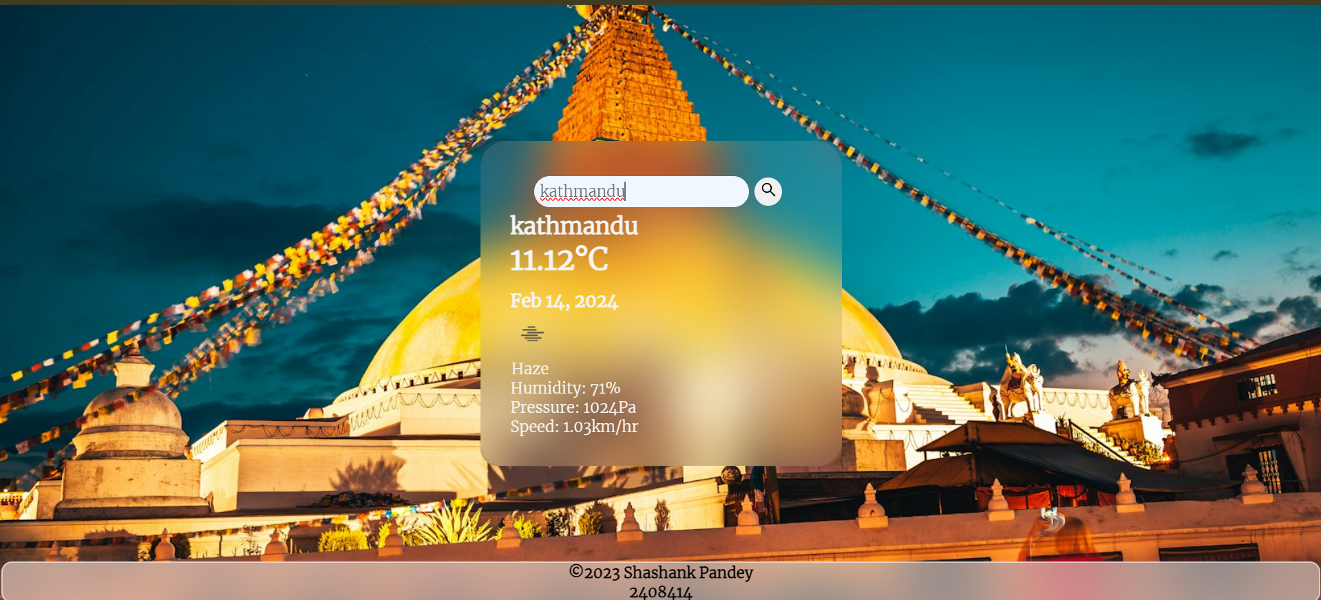

* Displaying “city not found” message whenever user inputs wrong city name:

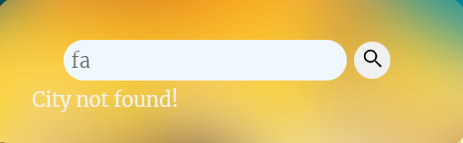

Strong Points:

* The weather data of default city and previous searched city is shown offline in the absence of internet connection.
* Since the weather app is hosted online, anyone can access the weather app.

Weak Points:

* Since the weather app is made through a simple architecture it won’t be able to handle complex issues.
* The app cannot show the past data of others except the default city and the app does not show hourly and weekly forecasts.

Web Hosting:

* In this prototype, I have successfully hosted my weather app online using two online web hosting applications i.e. Infinity free and 000webhost. Here while hosting my weather app, firstly I uploaded my weather files i.e. HTML file, CSS file, JS file and PHP file on both hosting application. Similarly, I created my database there and connected my database and my weather files. After connecting my database and weather files, the user is then able to access my weather app online with the help of the provided link.
* Link of infinity free hosting app:

<http://shashank77.kesug.com/weather.html>

* Result:

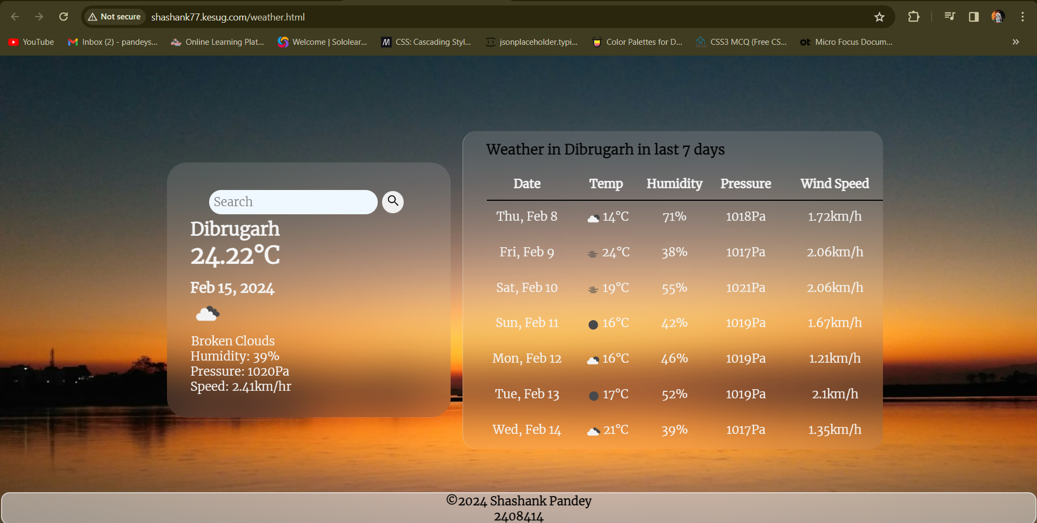

* Link of 000webhost hosting app:

<https://shashank7.000webhostapp.com/weather.html>

* Result:

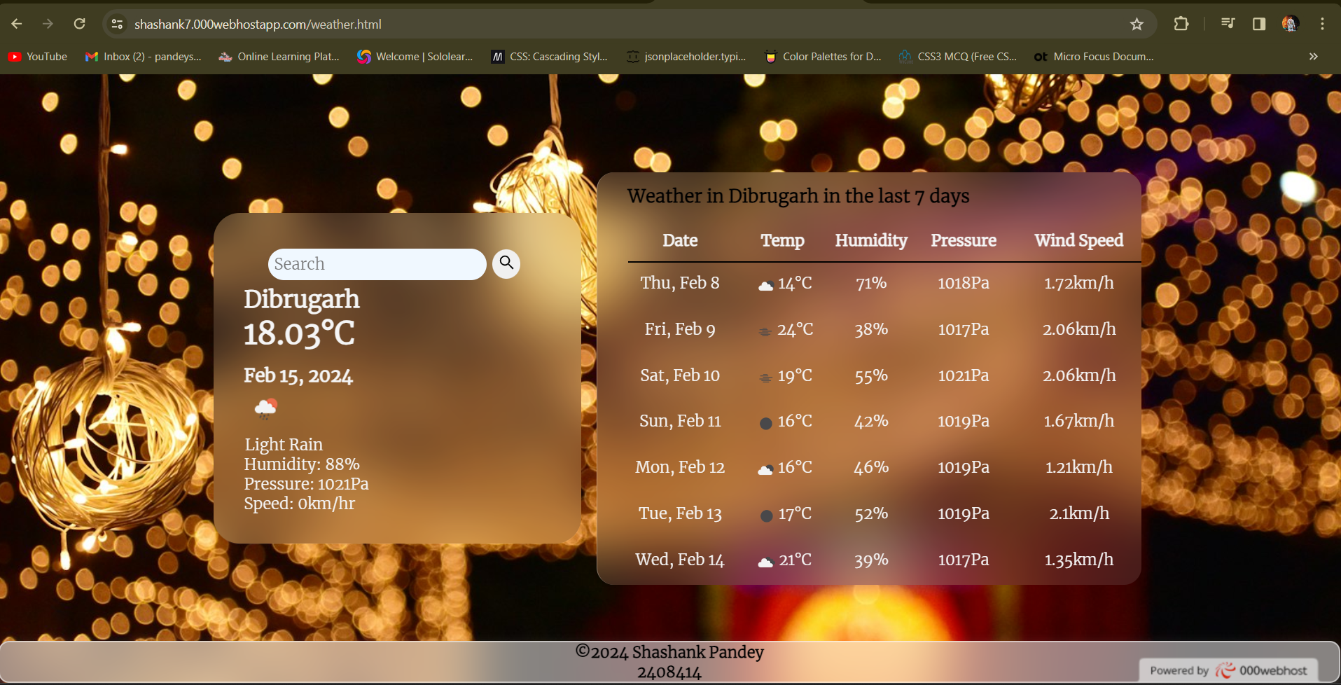

Local Storage:

* Local storage is simply browsers capability to store data on user’s device. In this prototype local storage is done in order to store the weather data of given city and also to use the save given data during the absence of internet connection. Here in this prototype, despite the absence of internet, user can access the weather data with the help of the data stored in local storage.
* Result:

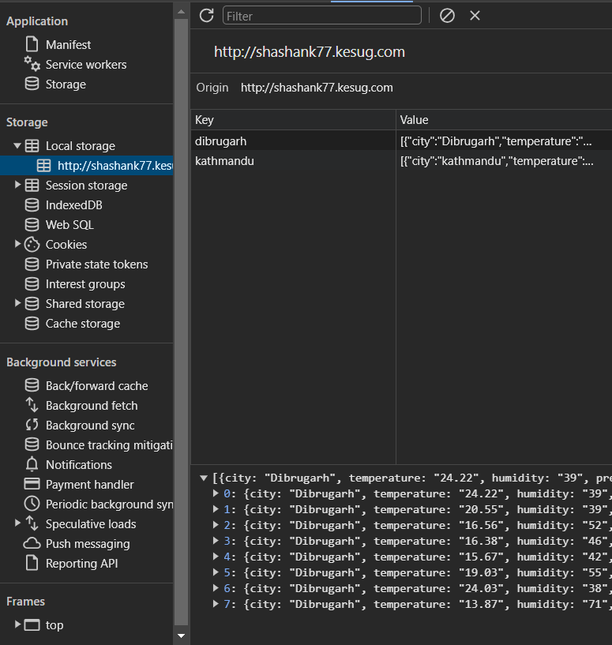

* Activity Diagram:

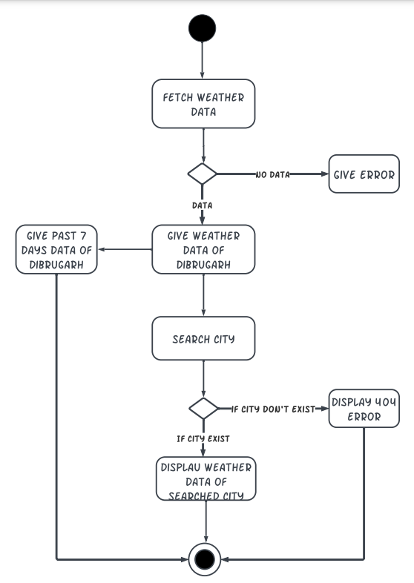

* Sequence Diagram:

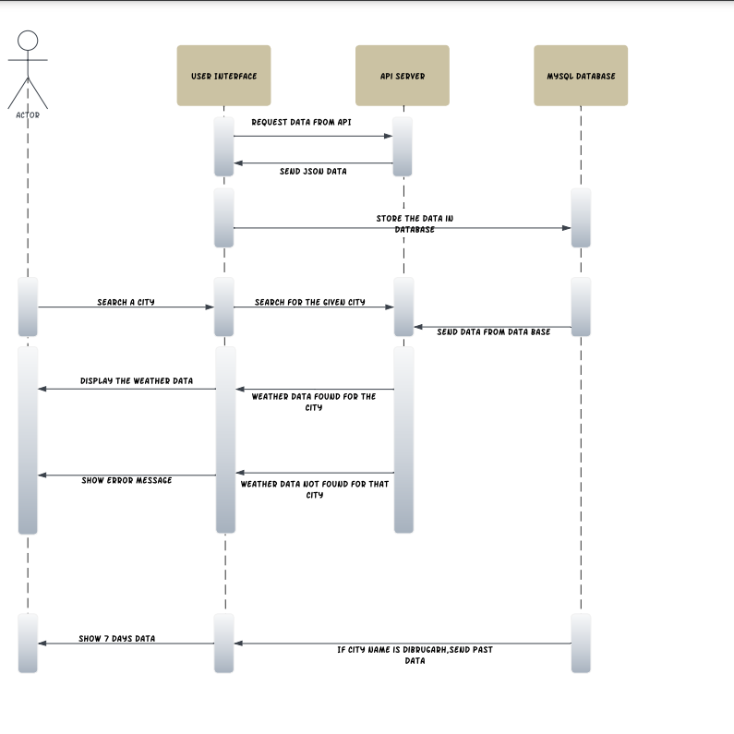

* Deployment Diagram:

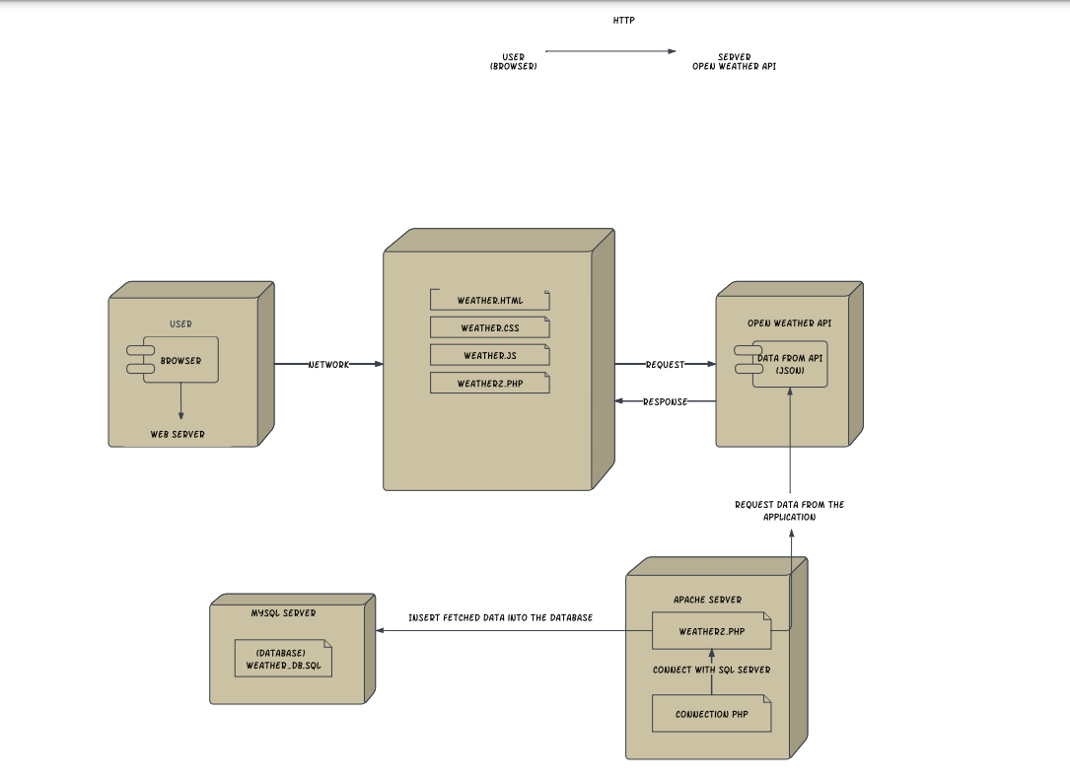

Conclusion:

* In conclusion, this coursework provides practical knowledge about the development of weather applications and also teaches students how to create, design and provide application logic to the project. This project also teaches students how to fetch the weather data through API and also engages students in creative and critical thinking activities. This weather app also teaches students how host the weather app online and to use the local storage in order to display weather of cities offline.